1. 
2. Threads are building blocks of concurrent app.
3. But working directly working threads has a couple of problems
   1. **Availability**: if you create a no of threads, you may run out of memory resulting in **OutOfMemoryException** thus our app would crash.
   2. **Cost**: Creating thread is costly. Suppose, we have 1000 images to download. If we can create only 10 threads at a time, when those threads complete, we need to create next set of 10 threads.
4. Java 5 gave a solution called 🡺 **Thread Pool**
5. **A thread pool** is essentially a pool of threads called **Worker Threads** and this thread can be reused to execute several tasks (Work). 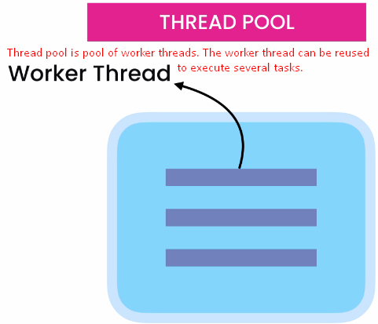
6. 